FOR IMMEDIATE RELEASE

Native Plant Trust Announces Event October 28 with Diane Wilson, award-winning author of The Seed Keeper

September 20, 2023
Media Contact: Bess Paupeck, Director of Public Programs, bpaupeck@NativePlantTrust.org
508.877.7630 x3302

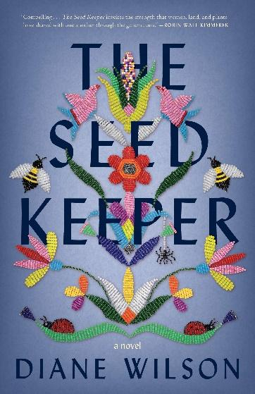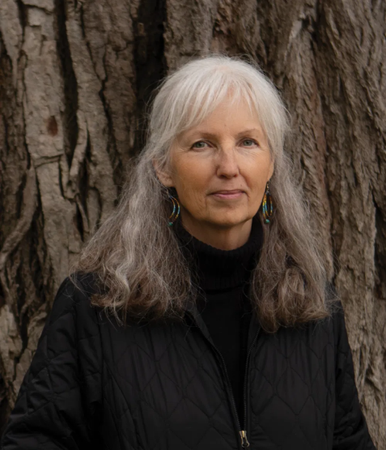

(Framingham, MA) Native Plant Trust, the nation’s first plant conservation organization and the only one solely focused on New England’s native plants, announces that Diane Wilson (Dakota) will speak about her award-winning book, The Seed Keeper. October 28, 2023, 3-4 PM, at the Cambridge Foundry in Kendall Square, Cambridge. The book talk and reading will be followed by a book signing.
A haunting novel spanning several generations, The Seed Keeper follows a Dakota family’s struggle to preserve their way of life, and their sacrifices to protect what matters most. As Americans of all backgrounds awaken to the importance of storing seeds for future generations, The Seed Keeper unfolds a timeless story of our relationship to seeds.
Bess Paupeck, Director of Public Programs at Native Pant Trust, shares:
“Native Plant Trust has a mission calling for seed-grown native plants, a desire to expand seed availability, room for expansion of our seed facilities, and expertise in all aspects of processing and banking seed and propagating even hard-to-grow New England native plants. While we are leading the way in the creation of a regional seed network, we are missing the Indigenous voice and perspective. Diane's presence as part of our programming lends an important, and missing, indigenous knowledge and perspective to our current conversations around the nature of seed processing, seed banking and propagation.”
Please visit www.NativePlantTrust.org for more information, registration and additional programs.
Praise for The Seed Keeper
"With compelling characters and images that linger long after the final page is turned, The Seed Keeper invokes the strength that women, land, and plants have shared with one another through the generations." —Robin Wall Kimmerer, author of Braiding Sweetgrass: Indigenous Wisdom, Scientific Knowledge, and the Teachings of Plants

"[The Seed Keeper] is a gorgeous and moving work of fiction with memorable characters that will stay in your heart and body for a long time." —BuzzFeed, "Brilliant Books That Explore Our Relationship with Nature"

"It's a moving multi-generational story about the destruction of Native American families, communities and lands--but also about reconnection, hope and the natural world . . . Wilson offers a different kind of idealism: one where community, family and the seeds can create the future we're seeking."—TODAY Show

ABOUT NATIVE PLANT TRUST
Native Plant Trust is the nation’s first plant conservation organization and the only one solely focused on New England’s native plants. We save native plants in the wild, grow them for gardens and restorations, and educate others on their value and use. We are based at Garden in the Woods, a renowned native plant botanic garden that attracts visitors from all over the world. From this flagship property in Framingham, Massachusetts, 30 staff and many of our 2,000 trained volunteers work throughout New England each year to monitor and protect rare and endangered plants, collect and preserve seeds to ensure biological diversity, detect and control invasive species, conduct research, and offer a range of educational programs. Native Plant Trust also operates a nursery at Nasami Farm in western Massachusetts and manages six sanctuaries in Maine, New Hampshire, and Vermont that are open to the public. Native Plant Trust is among the first organizations worldwide to receive Advanced Conservation Practitioner accreditation by London-based Botanic Gardens Conservation International (BGCI), which included an endorsement by an International Advisory Council representing six continents. Please visit www.NativePlantTrust.org.
###

